Digging for Britain: Black British Literature

English 553: Junior Seminar in Literature
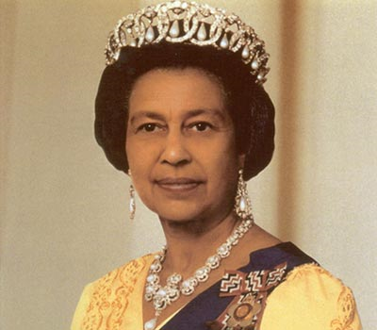
Required Texts:
Levy, Andrea. Fruit of the Lemon.
Levy, Andrea. Never Far From No Where.
Owusu, Kwesi. Black British Culture and Society.
Phillips, Caryl. The Falling Snow.
Selvon, Sam. The Lonely Londoners.
Dabydeen, David. The Intended.
Kwei-Armah, Kwame. Elimina’s Kitchen.
MLA Handbook, 7th edition
other readings available on Sakai

Course Overview:
This course will focus on fiction and literary criticism by Black British writers since the arrival of the Empire Windrush in 1948, as it examines the contested notions of Black Britishness in those works. Using “Black” in its least restricted sense to refer to people with an African heritage who have maintained a continuous presence on the British Isles as a consequence of such historical forces as the trans-Atlantic slave trade and Britain’s imperial ventures, this course is developed around the contested perception that the Black experience in Britain should be examined solely in terms of the twin stable paradigms of race and identity. The course questions the notion of a unitary “Black Experience”. It encourages students to examine contemporary Black British fiction as it is situated and forged by larger cultural forces that are mutable, and culturally and spatially non-static. Students will study how the Black British experience is complicated by, among other things, the Diaspora, displacement, racial admixture, gender and sexuality, and uncertain positions on nationhood.

Reading/Work Schedule (subject to change)

Wednesday 1/20 Course introduction

Monday 1/25 “Minimal Selves” (Sakai) & “Crossing the Seas” (Sakai)
Wednesday 1/27 “The Black Atlantic as a Counterculture of Modernity” (Owusu) & “Journey to
Death: Gilroy’s Black Atlantic”(Owusu)

Monday 2/1 The Lonely Londoners- p47
Wednesday 2/3 The Lonely Londoners - p93

Monday 2/8 The Lonely Londoners - end & “Home is Always Elsewhere” (Sakai)
Wednesday 2/10 Never Far From Nowhere- p86

Monday 2/15 Never Far From Nowhere- p180
Wednesday 2/17 Never Far From Nowhere- end & “The Liberation of the Black Intellectual” (Owusu)
1st Proposal and Annotated Bibliography due to Sakai, 3pm

Monday 2/22 The Intended- p53
Wednesday 2/24 The Intended- p 94

Monday 3/1 The Intended- end & “The Occasion for Speaking” (Owusu)
Wednesday 3/3 “Why Don’t You Just Stop Talking” (Sakai) & “On Seeing England for the First
Time” (Sakai)

Monday 3/8 Secrets and Lies (film)
Wednesday 3/10 Secrets and Lies (film)
1st Essay due to Sakai, 3pm

Monday 3/15 Elimina’s Kitchen- entire play
Wednesday 3/17 Elimina’s Kitchen &
“ ‘The Silent Catastrophe’: Institutional Racism in the British Educational System and the Underachievement of Black Boys” (Sakai)

Mon.- Wed. 3/22- 24 Spring Break

Monday 3/29 Cracker- “Men Should Weep” (BBC program)
Wednesday 3/31 Cracker- “Men Should Weep” (BBC program)

Monday 4/5 Fruit of the Lemon – Part I
Wednesday 4/7 Fruit of the Lemon
2nd Proposal and Annotated Bibliography due to Sakai, 3pm

Monday 4/12 Fruit of the Lemon– Part II & III
Wednesday 4/14 Fruit of the Lemon & “If I Could Write This in Fire, I Would Write this in Fire.” (Sakai)

Monday 4/19 The Falling Snow- p76
Wednesday 4/21 The Falling Snow- p146

Monday 4/26 The Falling Snow- p222
Wednesday 4/28 The Falling Snow- end & “Speaking in Tongues” (Sakai)

Monday 5/3 “The Rise and Fall of Black Britain” (Sakai)

Saturday 5/8 2nd Essay due to Sakai, noon

