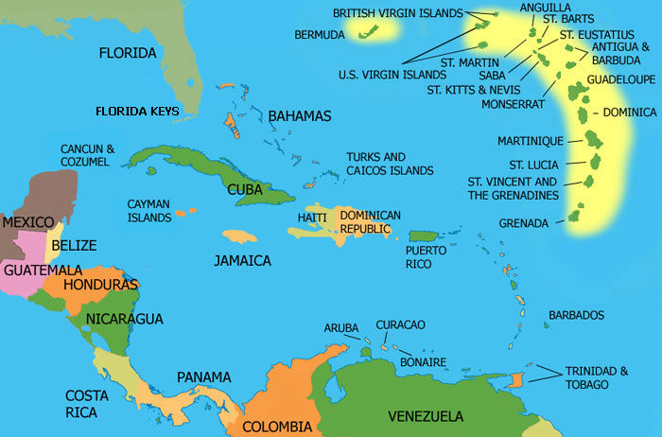
Not One but Many: Latinidad and Anglophone Caribbean Literatures
English 321: Literatures of Diversity of North America

Required texts:
Alvarez, Julia. In the Time of the Butterflies
Cliff, Michelle. No Telephone to Heaven
Danticat, Edwige. Breath, Eyes, Memory
Ferre, Rosario. Sweet Diamond Dust
Hodge, Merle. Crick Crack Monkey
Kincaid, Jamaica. A Small Place
Obejas, Achy. Memory Mambo
course readings (available on Sakai)

Objectives:
This course will focus on Afro-Caribbean and Latino/a-Caribbean literary texts, with a particular focus on the intersections of racial and linguistic identities. The Caribbean is a site of the literary histories of “the New World” yet historically literature courses center either on Afro-Caribbean literatures or Latino/a Caribbean literatures. In this class we will engage them together in order to highlight the complex literary history of what is often monolithically called “Caribbean literature.” We will have the opportunity to study the ways race, language, and identity converge and diverge in these literary texts and the complicated ways in which authors contend with histories of Spanish, British, and American imperialisms. Questions we may focus on include: what are the legacies of colonialisms in the Caribbeans we encounter textually? How and to what extent do race and language intersect in the authors’ conceptions of “the island” and of the emigration from it? Does gender and sexuality matter when considering linguistic and/or racial topographies? What is the role of family and nation in the dynamics of racial and linguistic identities as our authors and texts conceive of them?
Thursday, Jan. 19 Introductory theory
Tilling the Ground: Some Foundational Concepts
Tuesday, Jan. 24 “Introduction” to The Other America: Caribbean in a New World Context by J. Michael Dash (Sakai)
Thursday, Jan. 26 “If I Could Write this in Fire I Would Write this in Fire” by Michelle Cliff (Sakai) &
Allegories of Nationalism
Tuesday, Jan. 31 Sweet Diamond Dust, pp. vii- 85
Thursday, Feb 2 Sweet Diamond Dust, pp. 89- 118
Tuesday, Feb. 7 Sweet Diamond Dust, pp. 121- 197
Thursday, Feb. 9 “Latin, Latino, American: Split States and Global Imaginaries” by Professor Roman de la Campa (Sakai)

People Like Us: Making the Colonial Subject
Tuesday, Feb. 14 “Girl” By Jamaica Kincaid, “Popular Education in the West Indies in the 19th century” by Kenneth Ramchand & “On First Seeing England” by Kincaid (Sakai)
Thursday, Feb. 16 Crick Crack Monkey, pg vii- 76

Tuesday, Feb. 21 Crick Crack Monkey, pg 76- end
(Response paper #1 due on Sweet Diamond Dust)

Resistance on the Island
Thursday, Feb. 23 Breath, Eyes, Memory pg 3- 61

Tuesday, Feb. 28 Breath, Eyes, Memory pg 65- 174
Thursday, Mar. 1 Breath, Eyes, Memory pg 177- 236

Tuesday, March 6 Breath, Eyes, Memory continued
Family Pasts: The Violences and Vicissitudes of Love
Thursday, March 8 Memory Mambo pg 9-99

Tuesday, March 13 Memory Mambo pg 100-186
Thursday, March 15 Memory Mambo pg 187-237

Tuesday, March 20 Spring break
Thursday, March 22 Spring break
Tuesday, March 27 No Telephone to Heaven pg 1- 84
Thursday, March 29 No Telephone to Heaven pg 84- 140
(Response Paper #2 due on Breath Eyes Memory)
Tuesday, April 3 No Telephone to Heaven pg 140- 208
Thursday, April 5 No Telephone to Heaven continued
Tuesday, April 10 In the Time of the Butterflies, pg 3- 83
Thursday, April 12 In the Time of the Butterflies, pg 84- 147
(Proposal and Annotated Bibliography due)
Tuesday, April 17 In the Time of the Butterflies, pg 148- 256 (to page break)
Thursday, April 19 In the Time of the Butterflies, pg 257- 324

Allegories of Nationalism, Take II
Tuesday, April 24 A Small Place
Thursday, April 26 A Small Place
Tuesday, May 1 Muddying the Waters

Final essay due Saturday, May 5, 2012 @ noon to Sakai link

